**DAY 2**

**Task 1.1:Create Resource groups based on different project environments(eg., Development,Testing,Production).Explain the organizational benefits of using Resource groups.**

Step 1:Go to home page and select create a resources’

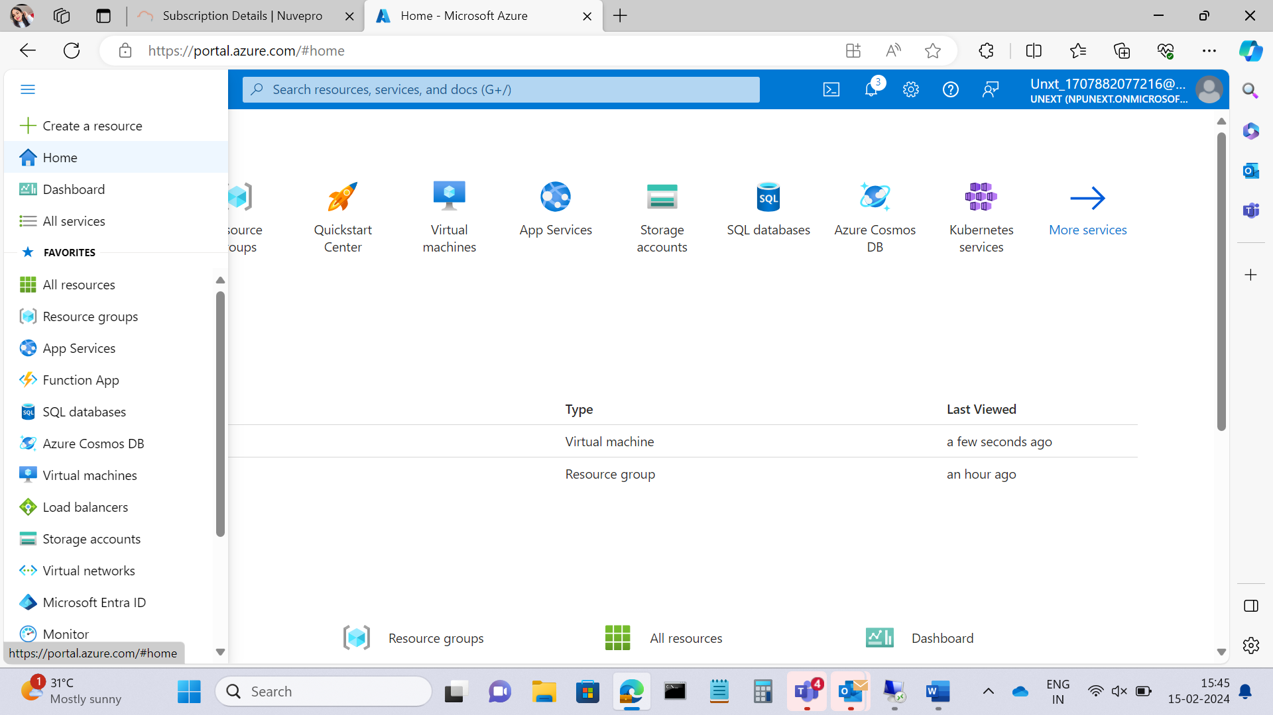

Step 2:then click on virtual machine

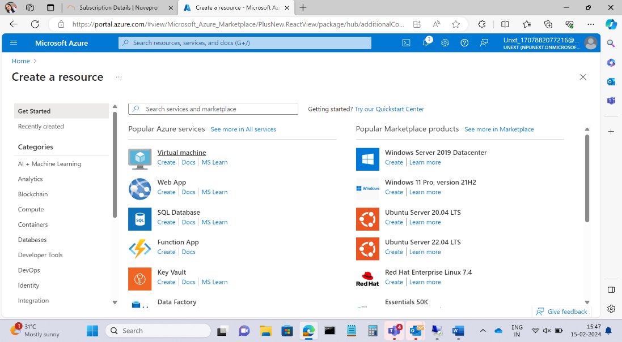

Step 3:Add Project details

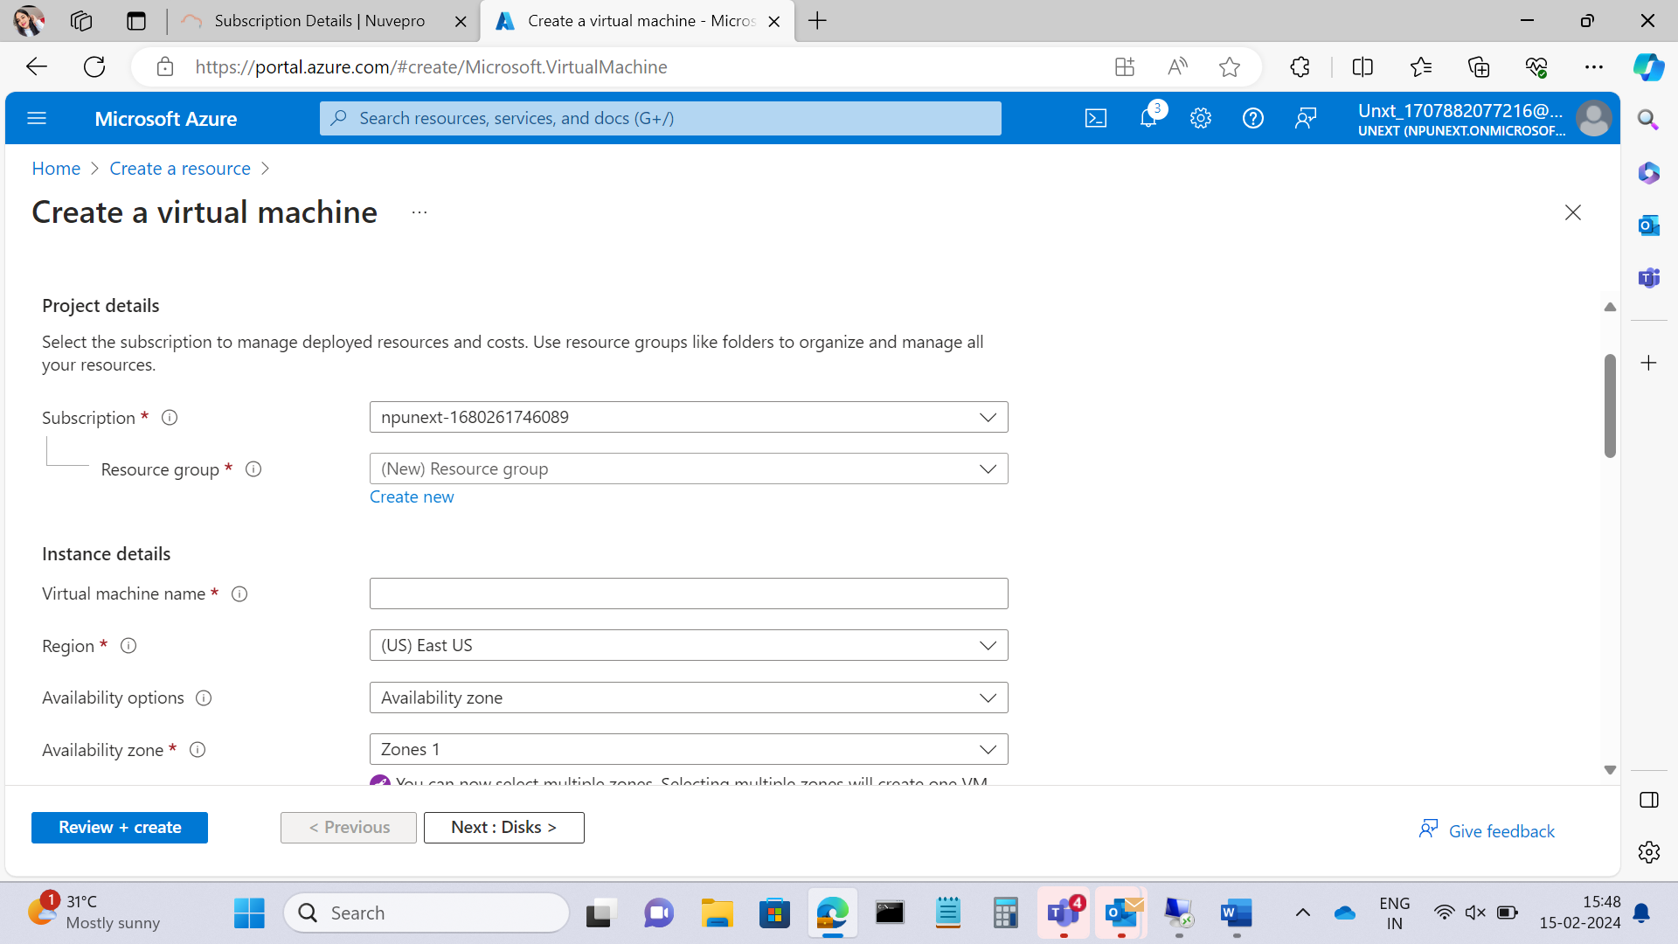

Step 4:Create new resources

Create 3 resource groups

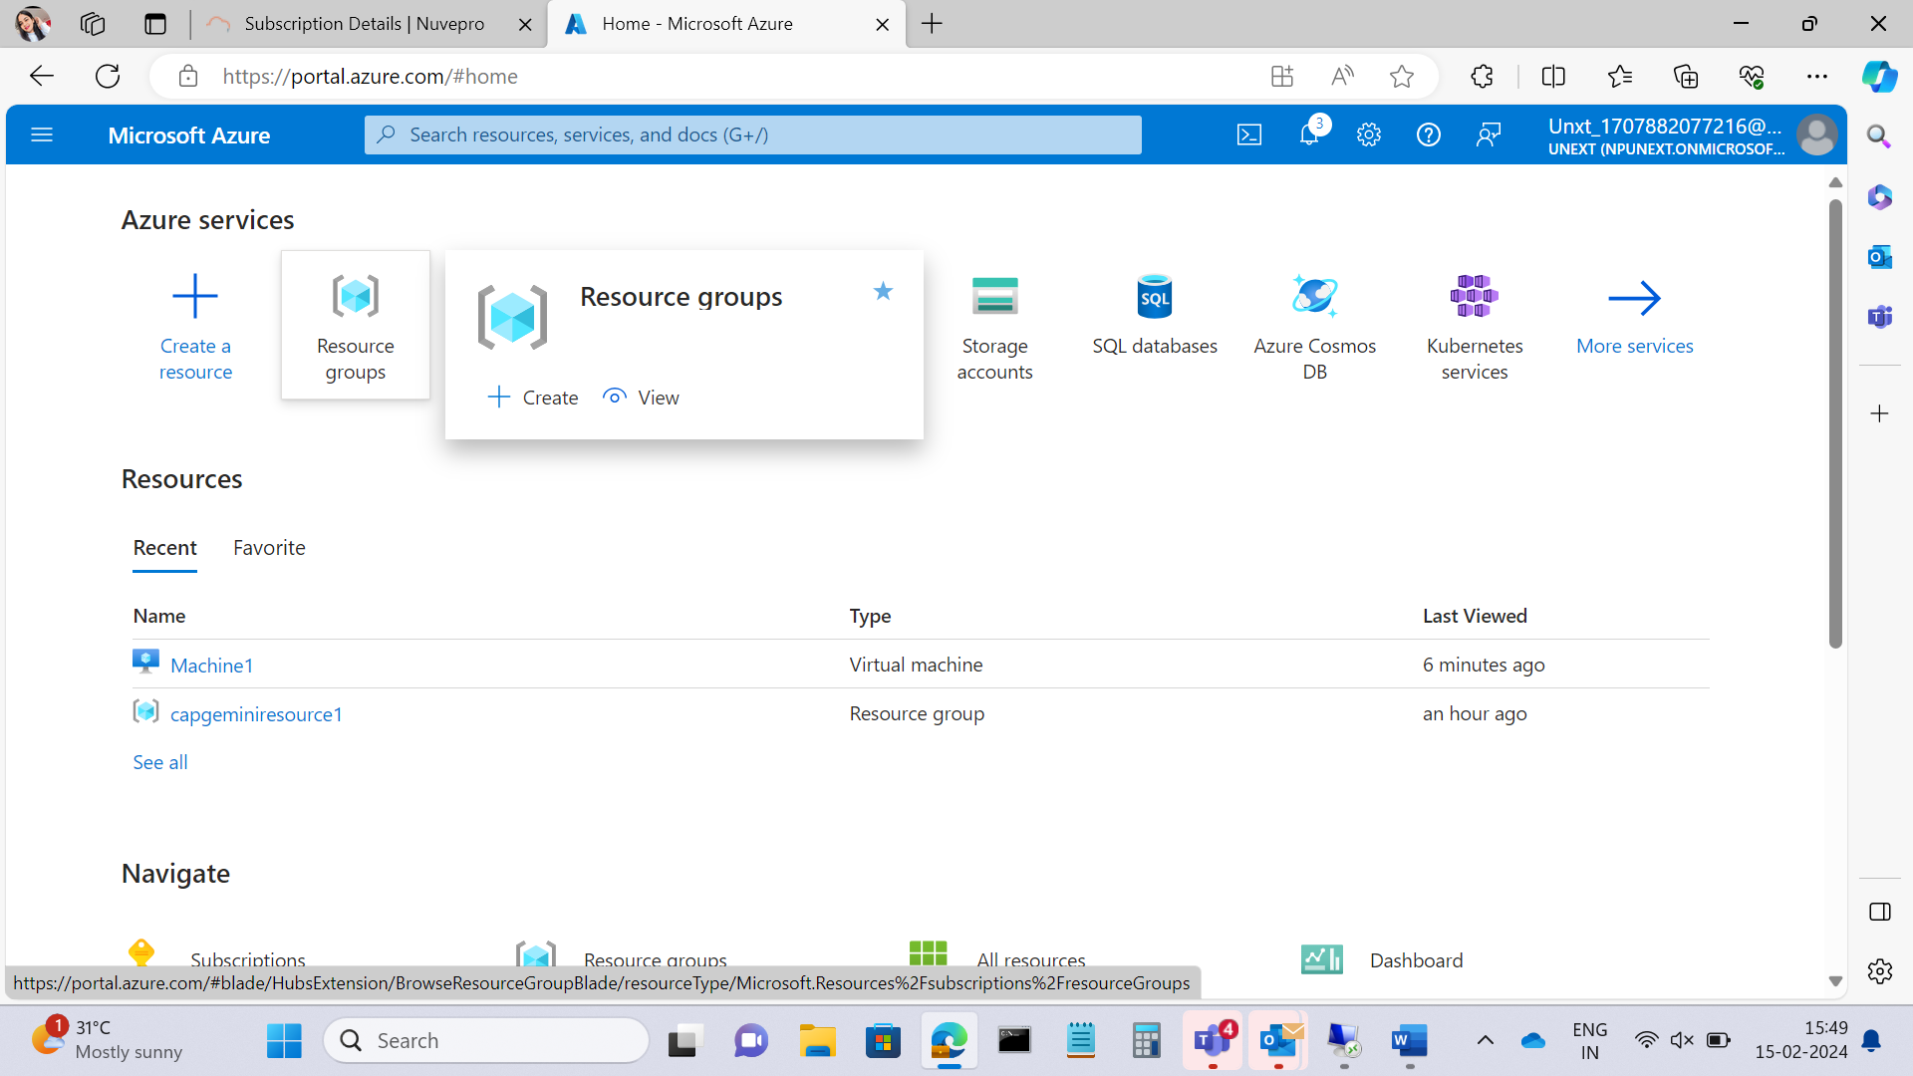

Step 5:here create resource groups

Step 6:After entering any name for resource enter review+create option and then create,so the named resource can be created.

Step 7:

Now go to your virtual machine page where you have to add project details.and select the resource groups you created and also create the zones and type of the Operating system..

Give one name for your virtual machine.

I have selected windows 11 pro operating system and then create a username and password where you have to remember it when you need to open the virtual machine you have created.

Under availability option select US east and select all three zones

Confirm the license and select review and create option and create

Step 8:there will be validation error so go to networking and select none option under Load balancing option

Here select none option under load balancing option,,,,,,click review and create.

Then deployment starts

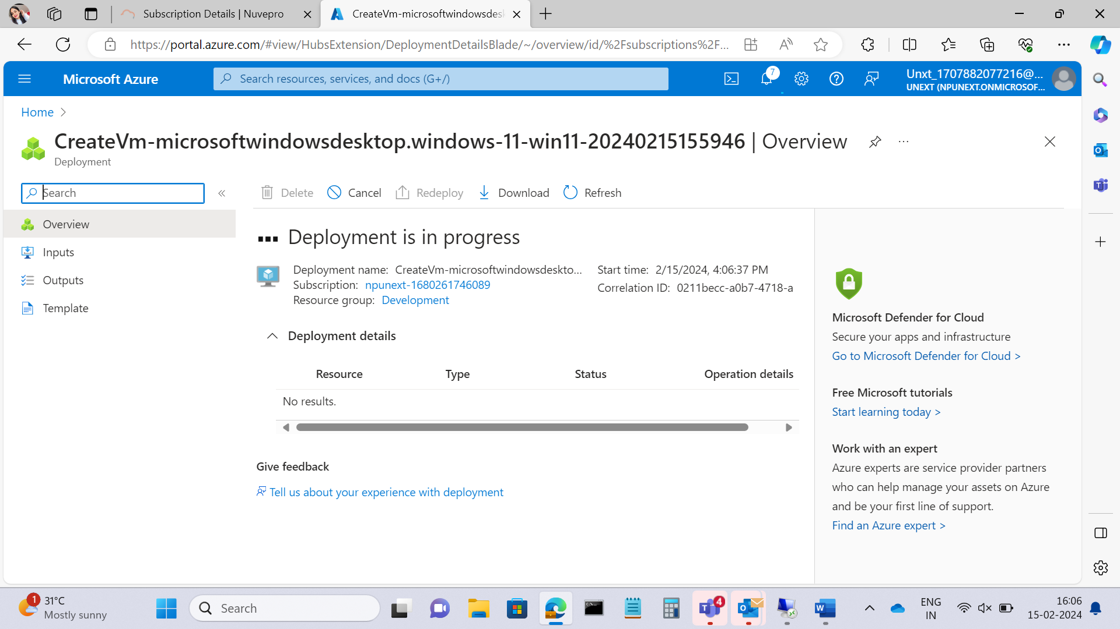

After deployment is completed by using your userID and password connect the virtual machine and the process is done.

**TASK 1.2:**

Explore and document the purpose and usage of availability zones and availability sets in ensuring application reliability,without creating VMs.

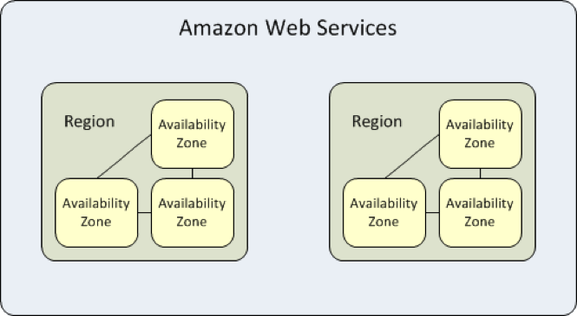

**Availability Zones:**

Purpose:

Availability Zones are distinct physical locations within a region, each having its own power, cooling, and networking. The primary purpose of Availability Zones is to provide high availability and fault tolerance by distributing resources across different data centers. In the event of a failure in one Availability Zone, the application can continue running in another without disruption.

Usage (Without Creating VMs):

1. **Data Storage:** You can use Availability Zones to store critical data redundantly. For example, by replicating data across different Availability Zones, you ensure data durability and availability even if one zone experiences a failure.
2. **Load Balancers:** Distributing your application's load balancers across Availability Zones helps in balancing the traffic. If one zone becomes unavailable, the load can be redirected to the healthy zones.
3. **Serverless Services:** Some serverless services, like Azure Functions or AWS Lambda, operate across Availability Zones by default. Developers do not explicitly create VMs, but the underlying infrastructure leverages Availability Zones for reliability.

**Availability Sets:**

Purpose:

An Availability Set is a logical grouping of VMs within a data center. The primary purpose is to ensure that VMs are distributed across multiple physical servers, racks, and network switches to reduce the risk of a single point of failure. In case of maintenance or a hardware failure, VM instances within an Availability Set are not affected simultaneously.

Usage (Without Creating VMs):

1. **Managed Databases:** In the context of managed databases or storage services, similar principles of Availability Sets can be applied. Distributing replicas or storage across different physical components enhances reliability.
2. **Containers and Kubernetes:** When deploying containerized applications or Kubernetes clusters, the concept of Availability Sets can be extended to ensure that different pods or containers are distributed across multiple nodes for resilience.
3. **Serverless Architectures:** For serverless architectures, the cloud provider often abstracts the underlying infrastructure, but the principles of distributing compute resources for resilience still apply.

Availability Zones and Availability Sets are commonly linked to Virtual Machines (VMs), but their application and control over the underlying infrastructure can be applied to other cloud services and architectures, depending on specific application requirements.